Can you simplify the code ref_snippet.java – remove duplicates and set the size of the frame to 400x400 pixels

DOCKERFILE

FROM openjdk:17-jdk-slim

# Step 2: Set the working directory in the container

WORKDIR /app

RUN apt-get update && apt-get install -y x11-apps

# Step 3: Copy the Java 17 application files into the container

COPY target/*.jar /app/*.jar

EXPOSE 8080

RUN apt-get update && apt-get install -y \

libxtst6 \

libxrender1 \

libxi6 \

libfreetype6 \

&& rm -rf /var/lib/apt/lists/*

# Set the DISPLAY environment variable

ENV DISPLAY=${DISPLAY}

CMD [ "java", "-cp", "*.jar", "org.example.Main"]

Dockerfile

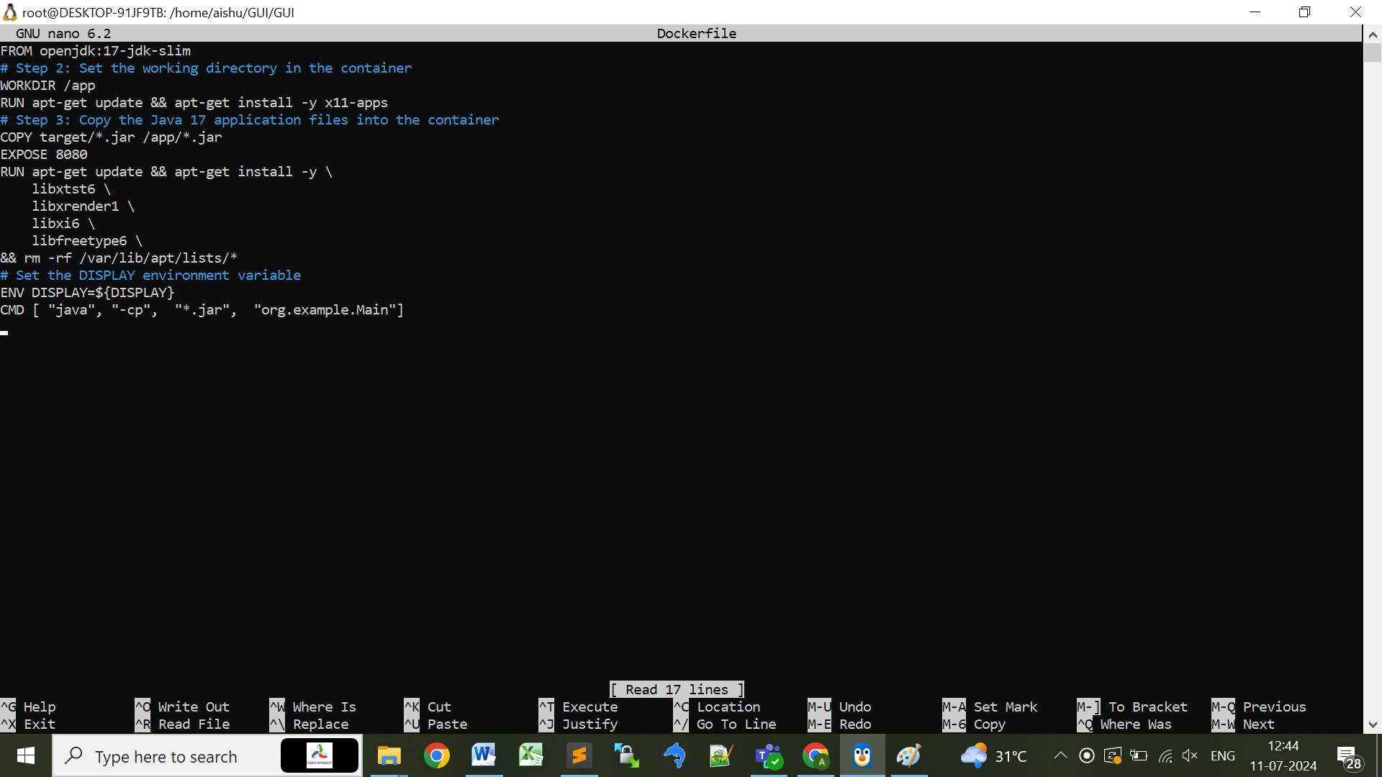

Output

docker build -t gui .

docker run -e DISPLAY=$DISPLAY -v /tmp/.X11-unix:/tmp/.X11-unix gui